Sunniday Agility

NEWSLETTER February 2007

Trainers for 2006
Lin Bergan
Indira Helsby
Carol Keane
Philippa Verstraete
Lisa Jordan
Don Nunn
Alison Grimes
Sue Julian

THE YEARS EVENTS
February… Fun Dog Party at Lingfield Hall
May…Osney Lodge Country Show

June…RSPCA…Demo and POTD

August…Edenbridge and Oxted Show…2days…Demos

Show Successes
Points gained in shows….
Winners 2006

Best in Category at Shows

ABC – David and Rusty
Best Beginner-David and Rusty
Best Elementary-Racheal and Jed
Best Starter-Steve and Pip
Best Novice –Gill and Greg
Best Senior- Candice and Ziggie
Best Mini –Peter and Biggles
Best Midi-Caroline and Muffin

Best Junior- Racheal and Jed
Best Over All-
Peter and Biggles

Fill in your forms to claim points for the club trophies.
The year runs from Jan1st to Dec 31st and includes all shows and Sunniday Club Competitions.
4th
Premier Division
2006

SUCCESSES

Supadogs Finals
Steve and Pip
Jon and Pocket
Finals at The Kennel Club Festival
Rachel and Jed.
Lin and Millie.
Caroline and Muffin
DIN Finals
Rachel and Jed
Pat and Red
Caroline and Muffin
Rescue League Finals
Pat and Red
Steve and Pip
Rachel and Jed

WINNING OUT IN 2006

Out of Elementary

Rachel and Jed
David and Rusty
Linda and Ash
Out of Starters
Steve and Pip
Corinne and Ralli
John and Pocket
David and Rusty
Linda and Ash
Pat and Red
Rachel and Tor
Jenny and Vicky
Rachel and Jed

Into Senior
Jill and Reuben
Indira and Ebony
Lin and Todd
David and Rusty
Caroline and Muffin
Barbara and Mackie

Into Advanced
Peter and Biggles

Classes From Jan 2007

Tuesdays
10.00 to 2.30 Private Lessons
  - Beginners
3.30 to 5.00 Private Lessons

New courses start Evenings Monday 26^{h} March
Wednesday 27th March
Thursday 28th March

Please note:
There are no classes week beginning 28th May

Please pay by CASH before the course starts.

Club Awards 2006

Sunniday Trophy
Sheila and Smudge

Fly Trophy
Candice and Ziggie
Best Young Handler
Racheal and Jed
Best Adult Handler
Margaret and Katie

Progress Cup
David and Darcy

Valgrays Rescue Trophy
Jan and Ozzie

The Benson Veteran Trophy
Frankie and Kellie

CRUFTS MARCH 2007
Good Luck to
Peter and Biggles, Lin and Millie, The BSD’s and to Helen and Jaz

AGILITY VOICE MAGAZINE

If you would like to subscribe to The Agility Voice Magazine and become a member of The Agility Club (a national club), this is the address to contact.
Virginia Harry
6 Fane Way
Maidenhead
Berkshire
SL6 2TL
Tel. 01628 680823

Send a cheque for £23.00 and a covering note.
You will be a member and receive the monthly magazine, be eligible for sponsored club events, have voting rights, and be able to send in your results for the year to appear on the national league tables.
If you start a membership please mention my name (Lin Bergan)

CLUB POINTS

If you send in your results as described in the magazine please register them with Sunniday Agility Club. That way they will be added to the club total.
You must send in Top 10 places only. 1st place has 10 points, 2nd place has 9 points and so on…

STONELEIGH PARK YOUR HORSE LIVE
NOVEMBER 2006
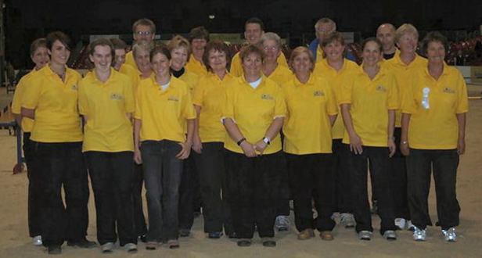

In November last year a group of handlers and dogs went to Stoneleigh near Coventry to do an agility demonstration. This was at the large event taking place there over a few days and run by Your Horse magazine. Sunniday Club and Valgrays Animal Rescue were asked to do an hour at the Saturday evening session. We were greeted very well, the audience loved the demo and the dogs and we raised lots for charity.
Total raised for charities in 2006 Hearing Dogs £1,500.00
E and O charities £400.00
Valgrays £700.00
Macmillan Nurses £500.00

Total £3,100.00

